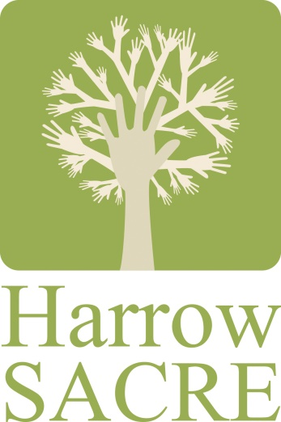
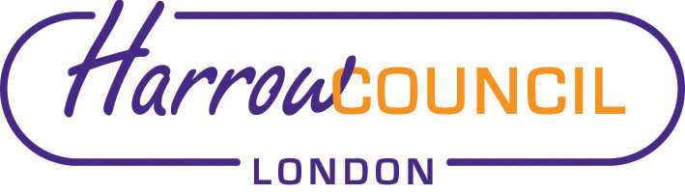
Harrow ASC and SACRE Meeting

Thursday 20 October 2022 at 7.30 p.m.
To be held in Committee Rooms 1 & 2 at Harrow Civic Centre

Enquiries & apologies to:
Vivian Wright, Clerk to SACRE
vmwright@waitrose.com

Adviser to SACRE: Lesley Prior

Agenda
- Welcome: we have a new representative for the Free Church Federal Council, Karen Collier, who is unable to be present this evening.

- Election Vice-Chair (held over from last meeting)

- Apologies for absence: Doreen Samuels, Karen Collier

- Minutes of the last meeting on 23 June 2022 (attached): to agree the minutes as a true record.

- Matters arising from the minutes

- ASC update

- Draft DRO for ratification

- Harrow workforce data

- 2021 Census data on religion

- Local and National updates

- Report on the NASACRE AGM and Conference

- RE Report Card

- News from Faith Groups relating to schools

- Any Other Business

- Future Dates

- Tues 6 Dec 2022
- Wed 1 March 2023

